

YEAR: 9
SUBJECT: SCIENCE

TEST: Matter
TIME: 50 mins
QUESTIONS: Part A: Multiple Choice Questions (10 marks)
Part B: Short Answer Questions (24 marks)
Part C: Extended Response (5 marks)

TOTAL MARKS: 39 marks

DO NOT WRITE ON OR MARK THIS PAPER

SECTION ONE: Multiple Choice Questions (1 mark each)
Answer this section on the separate multiple – choice answer sheet

- Which of the following statements about atoms is true?
- Neutrons and protons are found in the nucleus with the electrons
- The number of neutrons found in the nucleus of an atom is always the same
- Protons circle the nucleus all the time
- An atom is mostly empty space

- The nucleus of an atom is made up of
- electrons and protons
- protons and neutrons
- neutrons and electrons
- neutrons

- An ion is best defined as: An atom which has

- lost electrons
- gained electrons
- gained or lost electrons
- gained neutrons

- The atomic symbol for a gold atom is 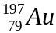. Clarify what this tells you about the gold atom.

- It contains 118 protons.
- It contains a total of 197 protons, neutrons and electrons.
- It contains 118 neutrons.
- It contains 197 electrons.

- What is the electronic configuration of a chlorine atom? Hint: Chlorine has an atomic number of 17.
- 2,2,2,2,2,2,2,2,1
- 2,8,7
- 8, 8, 1
- 2,10,5

- A phosphorus atom has an atomic number of 15. State how many electrons it has in its third (outermost) shell.

- 0
- 2
- 5
- 8

7. A radionuclide is:

- a radioactive isotope.
- a charged atom
- an element that emits beta radiation.
- an atom with the same number of protons but a different number of neutrons.

- The mass number of an atom is the number of

- neutrons in its nucleus.
- electrons in the nucleus.
- protons in the nucleus.
- protons plus neutrons in the nucleus.

- Which of the following will cause an atom to become a negative ion?
- gain electrons.
- lose protons.
- gain neutrons.
- lose neutrons.

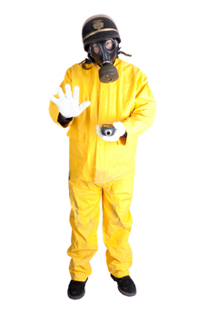
- Scientists use the process of decay in radioactive isotopes called to determine the of organisms.

- aging; carbon
- radioactive aging; carbon
- dating; age
- carbon dating; age


SEMESTER ONE 2018
Chemistry Test:
ANSWER BOOKLET
NAME:
FORM: DATE:

Multiple Choice Short Answer Extended Response Total

/10

/24

/39

/5

SECTION ONE: Multiple choice answers
Cross (X) through the correct answer.

1 | a | b | c | d
2 | a | b | c | d
3 | a | b | c | d
4 | a | b | c | d
5 | a | b | c | d
6 | a | b | c | d
7 | a | b | c | d
8 | a | b | c | d
9 | a | b | c | d
10 | a | b | c | d

SECTION TWO: Short Answer (28 marks)
Answer the questions in the spaces provided.

Question 11

Identify the number of protons, neutrons and electrons in the atom of potassium: (3 marks)
19
K
39.10

- protons:
- neutrons:
- electrons:

Question 12
For each of the electron configurations below, construct an electron diagram and write the name of the element you have drawn. (8 marks)

Electron Configuration: 2, 8, 1 Electron Configuration: 2, 7
Element: ______________ Element: ________________

Electron Configuration: 2, 8, 6 Electron Configuration: 2, 8
Element: ________________ Element: _______________
Question 13
Carbon has different isotopes, as shown in the diagram below.
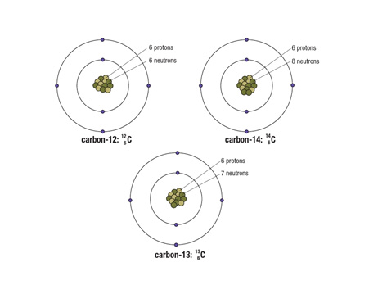
Describe the similarities and differences between these shown. (3 marks)

Question 14
The atoms below are written using the letters V to Z instead of their correct chemical symbols.
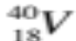 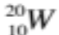 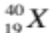 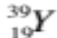 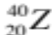 (4 marks)
- Which two atoms have the same number of neutrons?
______________________________________________________________________________
- Which atom has the smallest mass number?
______________________________________________________________________________
c) Which two atoms belong to the same element?
______________________________________________________________________________
- Which atom has the electron configuration 2, 8?
_____________________________________________________________________________
Question 15
This paragraph has some missing words. Their positions are numbered. (6 marks)
Ernest (1) proposed a new model for the atom where there is a small positively-charged (2) surrounded by (3) -charged electrons. Later on scientists discovered that there were two types of particles inside the nucleus—positively-charged (4) and neutrons, with no (5) . The number of protons is always the same as the number of (6) .

Which word goes in which position? Choose the correct word from the jumbled list below by writing each one in the correct numbered position:

charge electrons negatively nucleus protons Rutherford

(1) ____________________
(2) ____________________
(3) ____________________
(4) ____________________
(5) ____________________
(6) ____________________

SECTION THREE: Extended Response (5 marks)
Select ONE of the following questions and write the question number in the box below. Answer the question in the space provided.
- Explain why oxygen atoms ionise to form the oxide ion with a charge of –2. Identify if oxide is an anion or a cation.
- Some isotopes of the elements are unstable. This means they may undergo decay or change into another isotope and emit certain radiations.
- List three types of radiation in order from least penetrating to most penetrating.
- Compare the (similarities and differences) properties of those radiations. You need to show at least two properties for each radiations.
- What do you mean by the term half-life of a radioactive material?

Question Number:

END OF TEST
Please check your work!

